Penelope tidies her room

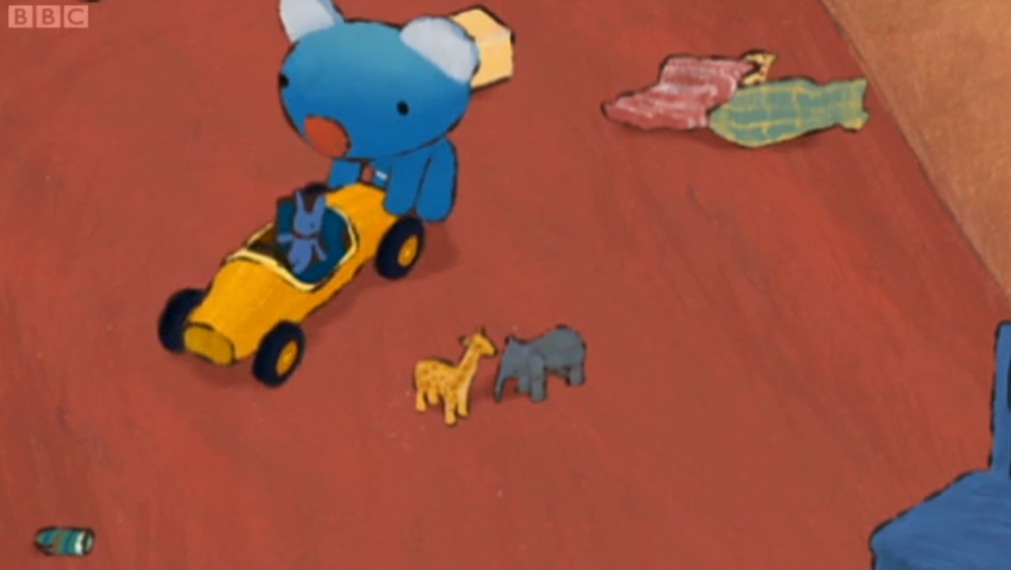

Ooh..Oh,max! Here we go! Beep.beep... beep!

Elephant and giraffe! Watch out! beep..beep!

What a mess! Is your room like this too?

I wonder what I should play with next.

oh, dear! Look at this mess.

Mum,mum, let’s play with the rings.

Penelope, why don’t you tidy your room first?

And then we’ll play with those.

Tidy up? It’s not that messy!

Well, I am going to go and clean and tidy the living room. Why don’t you tidy your room as well, Penelope?

Tidy up. Tidy up.

Now she’s carrying books. Do you know where to put the books?

That’s right. You put the books on the bookshelf.

Oh, no! oh, I found this sketch book. I am going to finish this cat. Kitty kitty, pretty kitty ... Finished!

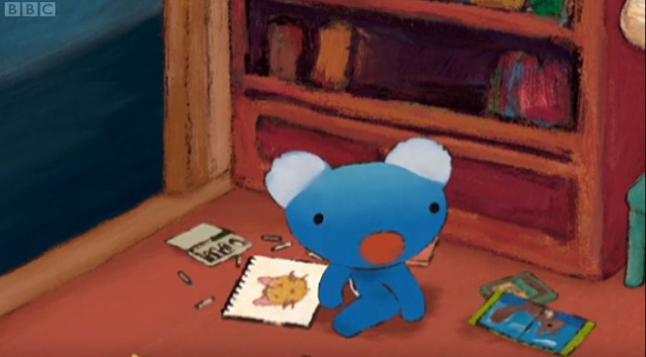

Next, I am going to add a butterfly.

Penelope, have you tidied your room yet?

Oh, I forgot I was tidying my room.

You forgot, Penelope?

Tidy up, tidy up.

The sketch book and crayons go here .Oh, no. I don’t like tidying up.

I’ve got an idea.

Oh, I wonder what Penelope’s idea is!

I can hide all the toys under the blanket. Then tidying would be easy. It’s a great idea.I will do it.

Penelope, what are you doing?

I had a great idea.

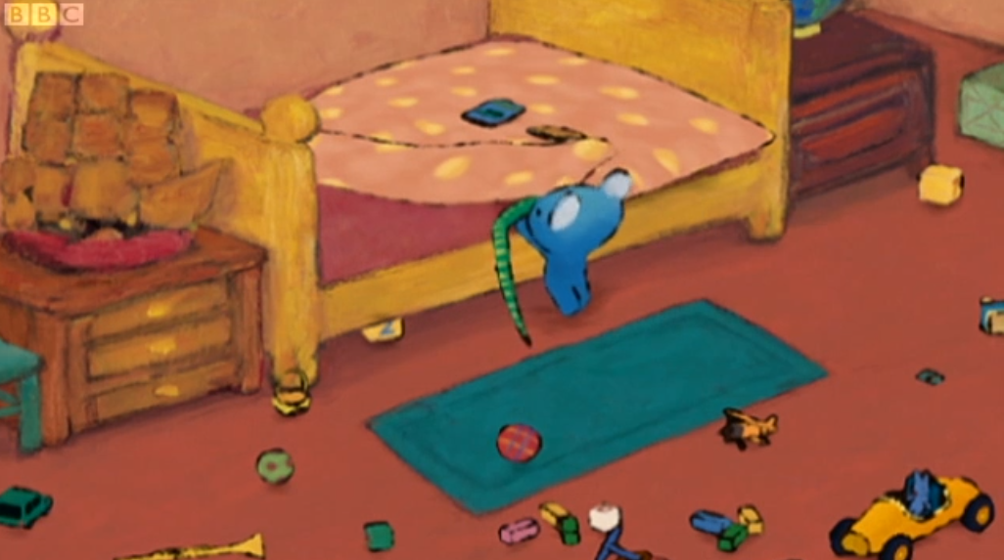

Oh, what is it?

Tell us Penelope.

It’s a secret.

What are you up to Penelope?

Wow, It’s nice and clean. Thanks to mum and dad.

Next time you will do it all by yourself, won’t you Penelope?